OctoberTour Restoration and Design Expo
Vendor Registration
Please complete the following form and email to dianeyoung96@gmail.com.
Vendor Company Name ___________________________________________________
Vendor Contact Name _____________________________________________________
Vendor Contact Email Address ______________________________________________
Vendor Contact Phone Number _____________________________________________
Vendor Category (choose one from below) ____________________________________
The October Tour Restoration and Design Expo is specifically for contractors, designers, suppliers, and professionals who provide goods or services for residential renovation/restoration projects. These include but are not limited to the following:
Designers: architects, engineers, interior designers (including kitchen and bath designers), landscape architects
Contractors: general contractors, painters, masons, landscapers, plumbing, mechanical and electrical contractors, flooring, walls, and finish contractors, hard tile contractors, wood workers, craftsmen
Suppliers and Professionals: windows and doors, millwork and casework, custom cabinetry and countertops, wall finishes (paint, wallpaper), hard tile, textiles, rugs, fireplace inserts and accessories, appliances, plumbing fixtures, lighting, and electrical fixtures, waterproofing and insulation, pavers and masonry products, yard décor, portrait artists, genealogical and archival professionals.
If you do not see your service or product on the above list, please email Diane Young at dianeyoung96@gmail.com to inquire about participation.

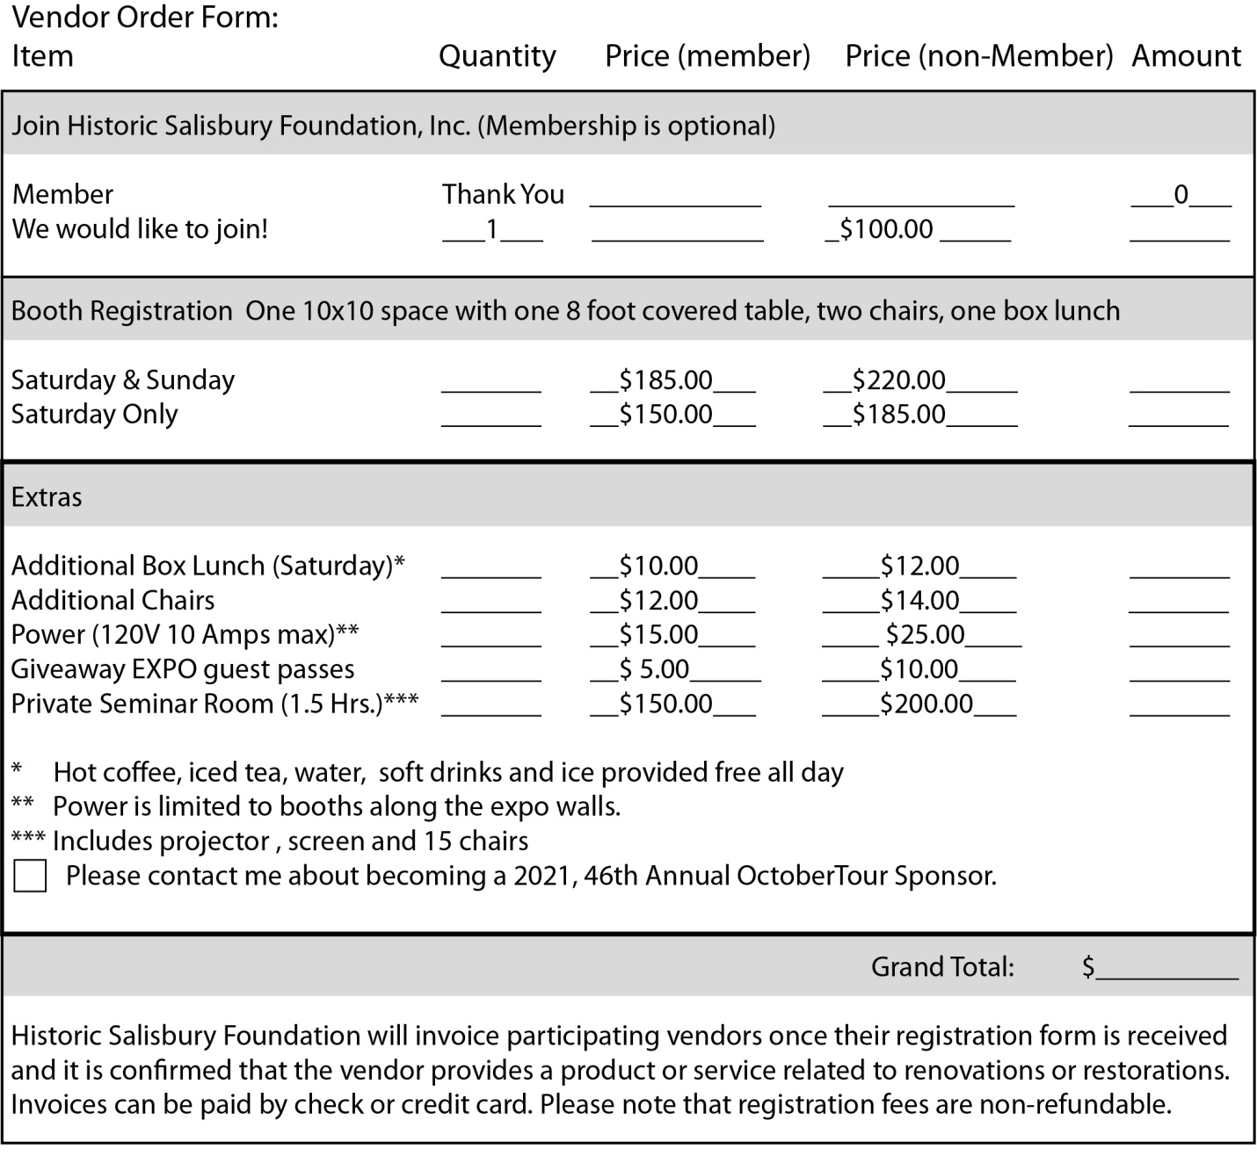
Setup/Breakdown
Setup: Vendors will set up on Friday, October 8 from 1:00 pm to 5:00 pm and again on Saturday, October 9 from 8:30 am to 9:30 am. All vendors must be in place and fully set up by 10:00 am on Saturday, October 9.
Breakdown: Saturday-only vendors will break down on Saturday, October 9 beginning at 5:30 pm. Breakdown must be completed by 6:30 pm on that day. Vendors participating both days will breakdown on Sunday, October 10 at 5:30 pm, breakdown must be completed by 6:30 pm on that day.
Please Note: Vendor breakdown cannot begin until 5:30 pm.
Signature
Signing and submitting this registration form confirms the vendor agrees to the following:
- Vendor spaces are limited to a total of forty booths. Vendor registration is confirmed when the registration fee is received by Historic Salisbury Foundation.
- Vendor understands that the registration fee is non-refundable.
- Vendor agrees to the setup and breakdown schedule as outlined above. Breakdown my not begin until 5:30 pm on each day.
Vendor Signature _____________________________________________________________

Please email Diane Young at dianeyoung96@gmail.com with any questions or for additional information.

